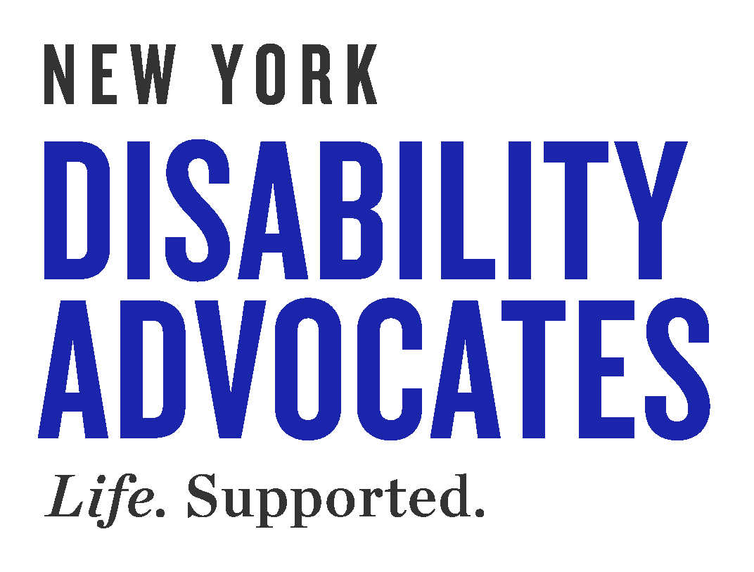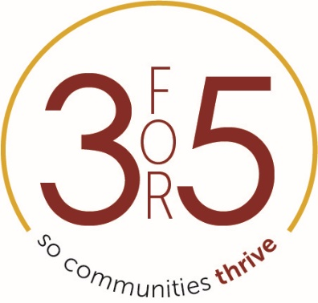

- Who am I:
  - My name is
  - I am a(n) [employee, parent, advocate, etc.] at [Insert Provider Agency]
  - I am your constituent.

- I am calling to urge you to support our 3for5 campaign for an annual 3% increase for 5 years, for nonprofit human services providers in New York State and here’s why:

  - For the past decade, nonprofits that support people with developmental disabilities have been asked to do more with less with $2.6 Billion in cuts and $5 Billion in lost revenues due to deferred COLA’s/Medicaid Trends.
  - OPWDD, which provides services identical to those provided by nonprofit providers, has increased its state-operated program rates by an average of 3% a year.
  - Nonprofit providers deliver approximately 85% of the day-to-day services for the more than 140,000 New Yorkers with developmental disabilities.
  - While there have been cuts and no increases, they have been forced to absorb increased costs in all areas of operations.
  - This has led to unsustainable staff vacancy and turnover rates and have brought many providers to the brink of insolvency.
  - In a recent survey, 1/3 of providers reported having just 2 pay periods worth of cash on hand.
  - On top of all this, the OPWDD Commissioner stated publicly that there will be a 2% rate cut effective July 1st of this year – all the more reason we need 3for5!

- Our ask:

  - Without your commitment to include 3for5 in this year’s budget, these nonprofit agencies are at serious risk of closure or program reductions impacting tens of thousands of employees and individuals receiving services.
  - [Give your own examples of why 3for5 is critical to you.]
  - Thank you for your consideration. I sincerely hope that you will lend your support and strongly advocate for the inclusion of 3for5 in the Assembly’s/Senate’s one house budget.

